目录
初始代码 1
1. 11
2. 14
3. 16
4. 19
5. 21
6. 24
7. 28
8. 31

初始代码
(注：以下所有尝试全部经过数据集缩减，但目前还不知道能不能这么缩减(╥_╥)，但是如果不缩减跑一个30 epoches要数小时，当前所有的尝试均为缩减为原来的0.1，详见代码，后面又有尝试分层训练（实验5、6）来优化结果，但其实都是缩减采样了的数据集，不是原有的完整数据集。)：

"""
Task 1.3: AI辅助编写ResNet-18训练代码
本脚本包含：数据加载、模型构建、训练、评估
"""
import os
import numpy as np
import matplotlib.pyplot as plt
from collections import Counter
from torch.utils.data import Subset
import torch
import torch.nn as nn
import torch.optim as optim
from torch.utils.data import DataLoader
from torchvision import transforms, models
import medmnist
from medmnist import INFO
plt.rcParams['font.sans-serif'] = ['SimHei'] # 用来正常显示中文标签
plt.rcParams['axes.unicode_minus'] = False # 用来正常显示负号

# ==================== 设置随机种子（保证结果可复现）====================
def set_seed(seed=42):
"""固定随机种子，让每次运行结果一致"""
np.random.seed(seed)
torch.manual_seed(seed)
if torch.cuda.is_available():
torch.cuda.manual_seed(seed)
torch.cuda.manual_seed_all(seed)

set_seed(42)

# ==================== 1. 配置参数 ====================
class Config:
"""所有可调参数集中管理，方便后续做对比实验"""
# 数据相关
data_root = os.path.join(os.path.dirname(os.path.abspath(__file__)), 'data')
image_size = 28 # ResNet通常用224，但OCTMNIST原始只有28，64是合理的
batch_size = 32 # 每批训练多少张图
num_workers = 0 # 数据加载线程数（Windows上设0最稳定）

# 模型相关
num_classes = 4 # CNV, DME, DRUSEN, NORMAL 四分类
pretrained = False # 不用预训练权重（OCTMNIST是灰度图，ImageNet是RGB）

# 训练相关
learning_rate = 0.001 # 学习率
num_epochs = 12 # 训练轮数
optimizer_name = 'Adam' # 优化器：'Adam' 或 'SGD'
loss_name = 'CrossEntropy' # 损失函数

# ===== 数据缩减（用于快速调参）=====
data_fraction = 0.1 # 1.0 表示用全部数据；0.1 表示只用10%

# 设备
device = torch.device('cuda' if torch.cuda.is_available() else 'cpu')

# 保存路径
save_dir = os.path.join(os.path.dirname(os.path.abspath(__file__)), 'results')

config = Config()
os.makedirs(config.save_dir, exist_ok=True)

print("=" * 60)
print("Task 1.3: ResNet-18 训练脚本")
print("=" * 60)
print(f"使用设备: {config.device}")
print(f"训练轮数: {config.num_epochs}")
print(f"批次大小: {config.batch_size}")
print(f"学习率: {config.learning_rate}")
print(f"优化器: {config.optimizer_name}")

# ==================== 2. 数据加载 ====================
print("\n" + "=" * 60)
print("2. 加载数据")
print("=" * 60)

# 训练集的数据增强
train_transform = transforms.Compose([
transforms.RandomRotation(10), # 随机旋转±10度（数据增强）
transforms.RandomHorizontalFlip(), # 随机水平翻转（数据增强）
transforms.ToTensor(),
transforms.Normalize(mean=[0.5], std=[0.5]) # 归一化到[-1,1]
])

# 验证集和测试集：不需要数据增强，只做归一化
eval_transform = transforms.Compose([
transforms.ToTensor(),
transforms.Normalize(mean=[0.5], std=[0.5])
])

# 加载三个数据集
train_dataset = medmnist.OCTMNIST(
root=config.data_root, split='train',
transform=train_transform, download=True, size=config.image_size
)

# ==================== 数据集缩减（用于快速调参）====================
if config.data_fraction < 1.0:
num_train = len(train_dataset)
indices = list(range(num_train))

np.random.shuffle(indices) # 随机打乱

subset_size = int(num_train * config.data_fraction)
selected_indices = indices[:subset_size]

train_dataset = Subset(train_dataset, selected_indices)

print("\n⚠️ 调参模式开启！")
print(f"训练集从 {num_train} → {subset_size}")

val_dataset = medmnist.OCTMNIST(
root=config.data_root, split='val',
transform=eval_transform, download=True, size=config.image_size
)
test_dataset = medmnist.OCTMNIST(
root=config.data_root, split='test',
transform=eval_transform, download=True, size=config.image_size
)

# 用DataLoader打包，让数据可以分批取出
train_loader = DataLoader(train_dataset, batch_size=config.batch_size,
shuffle=True, num_workers=config.num_workers)
val_loader = DataLoader(val_dataset, batch_size=config.batch_size,
shuffle=False, num_workers=config.num_workers)
test_loader = DataLoader(test_dataset, batch_size=config.batch_size,
shuffle=False, num_workers=config.num_workers)

print(f"训练集: {len(train_dataset)} 张, {len(train_loader)} 批")
print(f"验证集: {len(val_dataset)} 张, {len(val_loader)} 批")
print(f"测试集: {len(test_dataset)} 张, {len(test_loader)} 批")

# ==================== 3. 构建ResNet-18模型 ====================
print("\n" + "=" * 60)
print("3. 构建ResNet-18模型")
print("=" * 60)

def create_resnet18(num_classes=4, pretrained=False):
"""
创建ResNet-18模型
参数:
num_classes: 分类数
pretrained: 是否使用预训练权重
"""
# 从torchvision加载ResNet-18结构
model = models.resnet18(pretrained=pretrained)

# 关键：OCTMNIST是灰度图(1通道)，但ResNet默认接受RGB(3通道)
# 修改第一层卷积，从3通道改为1通道
model.conv1 = nn.Conv2d(
in_channels=1, # 输入1个通道（灰度图）
out_channels=64, # 输出64个特征图
kernel_size=7, # 卷积核大小
stride=2,
padding=3,
bias=False
)

# 修改最后的全连接层，输出4个类别（原来是1000类）
in_features = model.fc.in_features # 获取全连接层输入维度（512）
model.fc = nn.Linear(in_features, num_classes)

return model

# 创建模型并移到设备（CPU或GPU）
model = create_resnet18(num_classes=config.num_classes, pretrained=config.pretrained)
model = model.to(config.device)

# 计算模型参数量
total_params = sum(p.numel() for p in model.parameters())
trainable_params = sum(p.numel() for p in model.parameters() if p.requires_grad)
print(f"模型参数量: {total_params:,}")
print(f"可训练参数: {trainable_params:,}")
print(f"模型结构:\n{model}")

# ==================== 4. 定义损失函数和优化器 ====================
print("\n" + "=" * 60)
print("4. 损失函数与优化器")
print("=" * 60)

# 损失函数：交叉熵损失（分类任务标配）
# 它内部已经包含了Softmax，所以模型输出Logits即可
criterion = nn.CrossEntropyLoss()
print(f"损失函数: CrossEntropyLoss（内部包含Softmax）")

# 优化器
if config.optimizer_name == 'Adam':
optimizer = optim.Adam(model.parameters(), lr=config.learning_rate)
elif config.optimizer_name == 'SGD':
optimizer = optim.SGD(model.parameters(), lr=config.learning_rate, momentum=0.9)
print(f"优化器: {config.optimizer_name}")

# 学习率调度器：训练过程中逐渐降低学习率
scheduler = optim.lr_scheduler.StepLR(optimizer, step_size=10, gamma=0.1)
print(f"学习率调度: 每10轮降为原来的0.1倍")

# ==================== 5. 训练函数 ====================
from tqdm import tqdm # 文件开头加上这个导入

def train_one_epoch(model, loader, criterion, optimizer, device):
"""训练一个epoch"""
model.train()
total_loss = 0.0
correct = 0
total = 0

# 用tqdm包装loader，显示进度条
pbar = tqdm(loader, desc='Training', leave=False)

for inputs, targets in pbar:
inputs = inputs.to(device)
targets = targets.squeeze().to(device)

# 前向传播
outputs = model(inputs)
loss = criterion(outputs, targets)

# 反向传播
optimizer.zero_grad()
loss.backward()
optimizer.step()

# 统计
total_loss += loss.item() * inputs.size(0)
_, predicted = outputs.max(1)
total += targets.size(0)
correct += predicted.eq(targets).sum().item()

# 更新进度条显示
pbar.set_postfix({
'loss': f'{loss.item():.3f}',
'acc': f'{correct/total:.3f}'
})

avg_loss = total_loss / total
accuracy = correct / total
return avg_loss, accuracy

def evaluate(model, loader, criterion, device):
"""在验证集/测试集上评估"""
model.eval()
total_loss = 0.0
correct = 0
total = 0
all_preds = []
all_targets = []

pbar = tqdm(loader, desc='Evaluating', leave=False)

with torch.no_grad():
for inputs, targets in pbar:
inputs = inputs.to(device)
targets = targets.squeeze().to(device)

outputs = model(inputs)
loss = criterion(outputs, targets)

total_loss += loss.item() * inputs.size(0)
_, predicted = outputs.max(1)
total += targets.size(0)
correct += predicted.eq(targets).sum().item()

all_preds.extend(predicted.cpu().numpy())
all_targets.extend(targets.cpu().numpy())

pbar.set_postfix({'acc': f'{correct/total:.3f}'})

avg_loss = total_loss / total
accuracy = correct / total
return avg_loss, accuracy, all_preds, all_targets

# ==================== 6. 训练循环 ====================
print("\n" + "=" * 60)
print("5. 开始训练")
print("=" * 60)

# 记录每个epoch的指标（用于后续画图）
history = {
'train_loss': [], 'train_acc': [],
'val_loss': [], 'val_acc': []
}

best_val_acc = 0.0 # 记录最佳验证准确率

for epoch in range(config.num_epochs):
# 训练一个epoch
train_loss, train_acc = train_one_epoch(
model, train_loader, criterion, optimizer, config.device
)
print("训练完了一个epoch")

# 在验证集上评估
val_loss, val_acc, _, _ = evaluate(
model, val_loader, criterion, config.device
)
print("评估完毕")

# 更新学习率
scheduler.step()
current_lr = optimizer.param_groups[0]['lr']

# 保存历史记录
history['train_loss'].append(train_loss)
history['train_acc'].append(train_acc)
history['val_loss'].append(val_loss)
history['val_acc'].append(val_acc)

# 保存最佳模型
if val_acc > best_val_acc:
best_val_acc = val_acc
torch.save(model.state_dict(), os.path.join(config.save_dir, 'best_model.pth'))

# 打印进度
print(f"Epoch [{epoch+1:2d}/{config.num_epochs}] "
f"LR: {current_lr:.5f} | "
f"Train Loss: {train_loss:.4f} | Train Acc: {train_acc:.4f} | "
f"Val Loss: {val_loss:.4f} | Val Acc: {val_acc:.4f} "
f"{'★' if val_acc == best_val_acc else ''}")

print(f"\n训练完成！最佳验证准确率: {best_val_acc:.4f}")

# ==================== 7. 测试集评估 ====================
print("\n" + "=" * 60)
print("6. 测试集评估")
print("=" * 60)

# 加载最佳模型
model.load_state_dict(torch.load(os.path.join(config.save_dir, 'best_model.pth')))
test_loss, test_acc, test_preds, test_targets = evaluate(
model, test_loader, criterion, config.device
)
print(f"测试集 Loss: {test_loss:.4f}")
print(f"测试集 Accuracy: {test_acc:.4f}")

# ==================== 8. 绘制训练曲线 ====================
print("\n" + "=" * 60)
print("7. 绘制训练曲线")
print("=" * 60)

fig, axes = plt.subplots(1, 2, figsize=(14, 5))

# Loss曲线
axes[0].plot(range(1, config.num_epochs+1), history['train_loss'],
'b-', label='Train Loss', linewidth=2)
axes[0].plot(range(1, config.num_epochs+1), history['val_loss'],
'r-', label='Val Loss', linewidth=2)
axes[0].set_xlabel('Epoch', fontsize=12)
axes[0].set_ylabel('Loss', fontsize=12)
axes[0].set_title('训练和验证损失曲线', fontsize=14, fontweight='bold')
axes[0].legend()
axes[0].grid(True, alpha=0.3)

# Accuracy曲线
axes[1].plot(range(1, config.num_epochs+1), history['train_acc'],
'b-', label='Train Acc', linewidth=2)
axes[1].plot(range(1, config.num_epochs+1), history['val_acc'],
'r-', label='Val Acc', linewidth=2)
axes[1].set_xlabel('Epoch', fontsize=12)
axes[1].set_ylabel('Accuracy', fontsize=12)
axes[1].set_title('训练和验证准确率曲线', fontsize=14, fontweight='bold')
axes[1].legend()
axes[1].grid(True, alpha=0.3)

plt.tight_layout()
plt.savefig(os.path.join(config.save_dir, 'training_curves.png'), dpi=150)
plt.show()
print("✓ 训练曲线已保存")

# ==================== 9. 分类报告 ====================
print("\n" + "=" * 60)
print("8. 分类评估报告")
print("=" * 60)

from sklearn.metrics import classification_report, confusion_matrix

label_names = ['CNV', 'DME', 'DRUSEN', 'NORMAL']
print("\n分类报告:")
print(classification_report(test_targets, test_preds, target_names=label_names, digits=4))

# 混淆矩阵
cm = confusion_matrix(test_targets, test_preds)
print("\n混淆矩阵:")
print(cm)

# 可视化混淆矩阵
fig2, ax2 = plt.subplots(figsize=(8, 7))
im = ax2.imshow(cm, interpolation='nearest', cmap=plt.cm.Blues)
ax2.figure.colorbar(im, ax=ax2)
ax2.set(xticks=np.arange(cm.shape[1]),
yticks=np.arange(cm.shape[0]),
xticklabels=label_names,
yticklabels=label_names,
xlabel='预测类别',
ylabel='真实类别',
title='混淆矩阵')
# 在每个格子里写数字
for i in range(cm.shape[0]):
for j in range(cm.shape[1]):
ax2.text(j, i, str(cm[i, j]),
ha="center", va="center",
color="white" if cm[i, j] > cm.max()/2 else "black",
fontsize=12, fontweight='bold')
plt.tight_layout()
plt.savefig(os.path.join(config.save_dir, 'confusion_matrix.png'), dpi=150)
plt.show()
print("✓ 混淆矩阵已保存")

print("\n" + "=" * 60)
print("Task 1.3 基础训练完成！")
print(f"最佳模型保存在: {os.path.join(config.save_dir, 'best_model.pth')}")
print("=" * 60)

step_size = 10
batch_size = 32

============================================================
4. 损失函数与优化器
============================================================
损失函数: CrossEntropyLoss（内部包含Softmax）
优化器: Adam
学习率调度: 每10轮降为原来的0.1倍

============================================================
5. 开始训练
============================================================
Epoch [ 1/12] LR: 0.00100 | Train Loss: 0.8995 | Train Acc: 0.6808 | Val Loss: 0.8410 | Val Acc: 0.7208 ★
Epoch [ 2/12] LR: 0.00100 | Train Loss: 0.6862 | Train Acc: 0.7636 | Val Loss: 0.6263 | Val Acc: 0.7751 ★
Epoch [ 3/12] LR: 0.00100 | Train Loss: 0.6184 | Train Acc: 0.7892 | Val Loss: 0.5942 | Val Acc: 0.8010 ★
Epoch [ 4/12] LR: 0.00100 | Train Loss: 0.5718 | Train Acc: 0.8080 | Val Loss: 0.7180 | Val Acc: 0.7703
Epoch [ 5/12] LR: 0.00100 | Train Loss: 0.5502 | Train Acc: 0.8120 | Val Loss: 0.6674 | Val Acc: 0.7544
Epoch [ 6/12] LR: 0.00100 | Train Loss: 0.5333 | Train Acc: 0.8137 | Val Loss: 0.5156 | Val Acc: 0.8199 ★
Epoch [ 7/12] LR: 0.00100 | Train Loss: 0.5194 | Train Acc: 0.8233 | Val Loss: 0.4872 | Val Acc: 0.8325 ★
Epoch [ 8/12] LR: 0.00100 | Train Loss: 0.5110 | Train Acc: 0.8235 | Val Loss: 0.7495 | Val Acc: 0.7569
Epoch [ 9/12] LR: 0.00100 | Train Loss: 0.5032 | Train Acc: 0.8254 | Val Loss: 0.4954 | Val Acc: 0.8370 ★
Epoch [10/12] LR: 0.00010 | Train Loss: 0.4932 | Train Acc: 0.8310 | Val Loss: 0.6333 | Val Acc: 0.7948
Epoch [11/12] LR: 0.00010 | Train Loss: 0.4385 | Train Acc: 0.8449 | Val Loss: 0.4228 | Val Acc: 0.8517 ★
Epoch [12/12] LR: 0.00010 | Train Loss: 0.4242 | Train Acc: 0.8500 | Val Loss: 0.4150 | Val Acc: 0.8556 ★

训练完成！最佳验证准确率: 0.8556

============================================================
6. 测试集评估
============================================================
测试集 Loss: 0.7855 测试集 Accuracy: 0.6780

============================================================
7. 绘制训练曲线
============================================================
✓ 训练曲线已保存

============================================================
8. 分类评估报告
============================================================

分类报告:
precision recall f1-score support

CNV 0.6067 0.9440 0.7387 250
DME 0.9130 0.7560 0.8271 250
DRUSEN 0.7917 0.0760 0.1387 250
NORMAL 0.6158 0.9360 0.7429 250

accuracy 0.6780 1000
macro avg 0.7318 0.6780 0.6118 1000
weighted avg 0.7318 0.6780 0.6118 1000

混淆矩阵:
[[236 10 1 3]
[ 46 189 0 15]
[ 97 6 19 128]
[ 10 2 4 234]]
✓ 混淆矩阵已保存
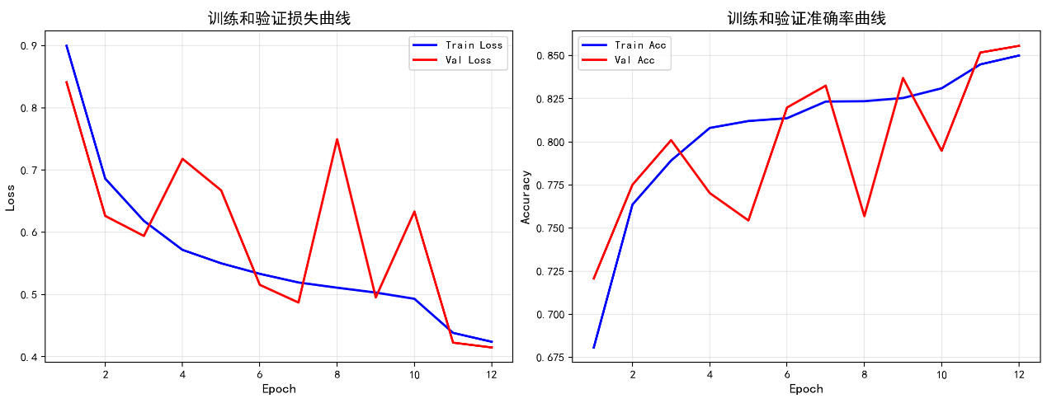

一、 图表分析：说明了什么信息？
1. 训练曲线（蓝色实线）非常健康：
- Train Loss 平稳下降，Train Acc 平稳上升。这说明模型在训练集上学到了规律，收敛性好，没有出现“无法拟合”的现象。
2. 验证曲线（红色实线）存在严重问题：
- 剧烈的波动（高方差）：在Epoch 7-11之间，Val Loss 从0.5左右飙升至0.75再跌回0.5，Val Acc 同时出现大幅度的锯齿状震荡。
- 潜在过拟合迹象（尽管目前差异不大）：虽然最后几个Epoch验证集准确率也很高，但中间的剧烈震荡表明模型对验证集的预测非常不稳定。
3. 总结结论：
- 模型学习能力没问题（训练集表现好）。
- 模型泛化能力不稳定。这通常意味着模型对训练数据的细节（噪声）过于敏感，或者训练设置（如学习率、Batch Size）导致梯度更新出现震荡，而不是平稳滑向谷底。
二、 如何调整模型参数使效果更佳？
针对上述“验证集剧烈震荡、训练集稳定下降”的情况，推荐以下调整方案（按推荐优先级排序）：
1. 解决学习率问题（最可能的根本原因）
这种锯齿状震荡通常是学习率（Learning Rate）过大导致的。
- 调整方法：
  - 将初始学习率调低，例如从当前的 0.01 或 0.001 降低到 0.0005 或 0.0001。
  - 如果不想手动调，可以引入学习率衰减策略（如 StepLR 或 CosineAnnealingLR），每几个Epoch让学习率变小。
2. 检查 Batch Size（批次大小）
Batch Size 太小会导致梯度计算包含大量噪声，引起Loss震荡。
- 调整方法：尝试将 Batch Size 加倍（例如从 32 改为 64）。如果显存允许，可以用 128，这通常会让 Loss 曲线更平滑。
3. 引入正则化手段（防止过拟合，提高稳定性）
- Dropout：在全连接层之前增加 Dropout 层，例如设置 dropout=0.3 或 0.5。这会强制模型学习更具鲁棒性的特征。
- 权重衰减 (Weight Decay)：在优化器（如 Adam 或 SGD）中增加 weight_decay 参数。建议从 1e-4 或 1e-5 开始尝试。
4. 检查数据预处理与归一化
- 归一化：确保输入数据不是简单的 [0, 255] 或未归一化的数值，而应该缩放到 [0, 1] 或进行标准正态分布标准化（均值0，方差1）。
- 增强数据：如果数据量较少，强制加一些轻微的噪声或变形，能提高模型对验证集的稳定性。
5. 提前停止（Early Stopping）
目前的训练显示到 Epoch 11-12 时，验证集效果反而不如之前稳定。
- 策略：设置验证集Loss在连续 N 轮（如 3-5 轮）不下降时，停止训练并保存最佳模型权重，而不是跑满预设的Epoch。

——————————————————————————————————————————————————————————————————————————————————————————————————————————————————————————————————————————————————————————————————————————————————————————————————————————————————————

2.
step_size = 3
batch_size = 32

============================================================
4. 损失函数与优化器
============================================================
损失函数: CrossEntropyLoss（内部包含Softmax）
优化器: Adam
学习率调度: 每10轮降为原来的0.1倍

============================================================
5. 开始训练
============================================================
Epoch [ 1/12] LR: 0.00100 | Train Loss: 0.8995 | Train Acc: 0.6808 | Val Loss: 0.8410 | Val Acc: 0.7208 ★
Epoch [ 2/12] LR: 0.00100 | Train Loss: 0.6862 | Train Acc: 0.7636 | Val Loss: 0.6263 | Val Acc: 0.7751 ★
Epoch [ 3/12] LR: 0.00010 | Train Loss: 0.6184 | Train Acc: 0.7892 | Val Loss: 0.5942 | Val Acc: 0.8010 ★
Epoch [ 4/12] LR: 0.00010 | Train Loss: 0.5329 | Train Acc: 0.8175 | Val Loss: 0.5042 | Val Acc: 0.8256 ★
Epoch [ 5/12] LR: 0.00010 | Train Loss: 0.5053 | Train Acc: 0.8235 | Val Loss: 0.4895 | Val Acc: 0.8260 ★
Epoch [ 6/12] LR: 0.00001 | Train Loss: 0.4914 | Train Acc: 0.8284 | Val Loss: 0.4765 | Val Acc: 0.8326 ★
Epoch [ 7/12] LR: 0.00001 | Train Loss: 0.4767 | Train Acc: 0.8346 | Val Loss: 0.4659 | Val Acc: 0.8353 ★
Epoch [ 8/12] LR: 0.00001 | Train Loss: 0.4761 | Train Acc: 0.8321 | Val Loss: 0.4669 | Val Acc: 0.8360 ★
Epoch [ 9/12] LR: 0.00000 | Train Loss: 0.4757 | Train Acc: 0.8341 | Val Loss: 0.4627 | Val Acc: 0.8378 ★
Epoch [10/12] LR: 0.00000 | Train Loss: 0.4726 | Train Acc: 0.8355 | Val Loss: 0.4620 | Val Acc: 0.8380 ★
Epoch [11/12] LR: 0.00000 | Train Loss: 0.4712 | Train Acc: 0.8350 | Val Loss: 0.4619 | Val Acc: 0.8374
Epoch [12/12] LR: 0.00000 | Train Loss: 0.4786 | Train Acc: 0.8324 | Val Loss: 0.4627 | Val Acc: 0.8362

训练完成！最佳验证准确率: 0.8380

============================================================
6. 测试集评估
============================================================
测试集 Loss: 0.8183 测试集 Accuracy: 0.6580

============================================================
7. 绘制训练曲线
============================================================
✓ 训练曲线已保存

============================================================
8. 分类评估报告
============================================================

分类报告:
precision recall f1-score support

CNV 0.5875 0.9400 0.7231 250
DME 0.8930 0.7680 0.8258 250
DRUSEN 0.5000 0.0080 0.0157 250
NORMAL 0.6010 0.9160 0.7258 250

accuracy 0.6580 1000
macro avg 0.6454 0.6580 0.5726 1000
weighted avg 0.6454 0.6580 0.5726 1000

混淆矩阵:
[[235 14 0 1]
[ 43 192 0 15]
[105 7 2 136]
[ 17 2 2 229]]
✓ 混淆矩阵已保存
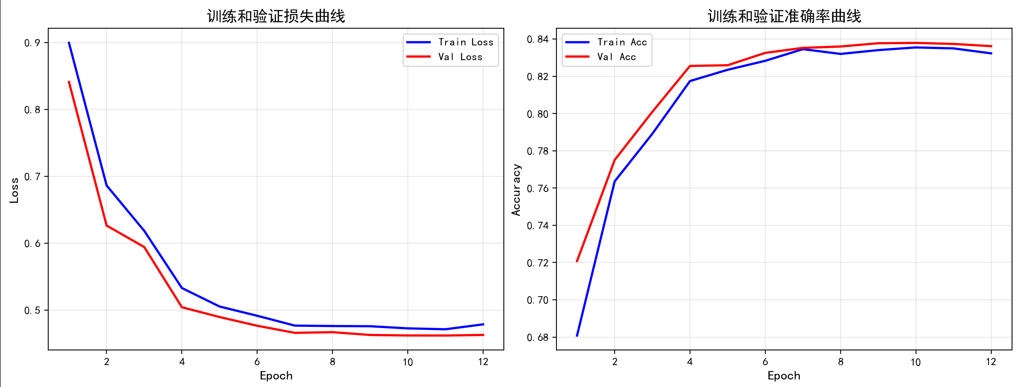

——————————————————————————————————————————————————————————————————————————————————————————————————————————————————————————————————————————————————————————————————————————————————————————

3.
step_size = 3
batch_size = 64

============================================================
4. 损失函数与优化器
============================================================
损失函数: CrossEntropyLoss（内部包含Softmax）
优化器: Adam
学习率调度: 每10轮降为原来的0.1倍

============================================================
5. 开始训练
============================================================
Epoch [ 1/12] LR: 0.00100 | Train Loss: 0.9094 | Train Acc: 0.6703 | Val Loss: 0.8241 | Val Acc: 0.7213 ★
Epoch [ 2/12] LR: 0.00100 | Train Loss: 0.6684 | Train Acc: 0.7717 | Val Loss: 0.6605 | Val Acc: 0.7866 ★
Epoch [ 3/12] LR: 0.00010 | Train Loss: 0.6107 | Train Acc: 0.7893 | Val Loss: 0.6832 | Val Acc: 0.7742
Epoch [ 4/12] LR: 0.00010 | Train Loss: 0.5285 | Train Acc: 0.8165 | Val Loss: 0.5107 | Val Acc: 0.8202 ★
Epoch [ 5/12] LR: 0.00010 | Train Loss: 0.5031 | Train Acc: 0.8235 | Val Loss: 0.5051 | Val Acc: 0.8228 ★
Epoch [ 6/12] LR: 0.00001 | Train Loss: 0.4904 | Train Acc: 0.8270 | Val Loss: 0.4831 | Val Acc: 0.8296 ★
Epoch [ 7/12] LR: 0.00001 | Train Loss: 0.4727 | Train Acc: 0.8332 | Val Loss: 0.4813 | Val Acc: 0.8313 ★
Epoch [ 8/12] LR: 0.00001 | Train Loss: 0.4711 | Train Acc: 0.8339 | Val Loss: 0.4797 | Val Acc: 0.8320 ★
Epoch [ 9/12] LR: 0.00000 | Train Loss: 0.4722 | Train Acc: 0.8358 | Val Loss: 0.4761 | Val Acc: 0.8323 ★
Epoch [10/12] LR: 0.00000 | Train Loss: 0.4671 | Train Acc: 0.8352 | Val Loss: 0.4755 | Val Acc: 0.8325 ★
Epoch [11/12] LR: 0.00000 | Train Loss: 0.4651 | Train Acc: 0.8349 | Val Loss: 0.4749 | Val Acc: 0.8324
Epoch [12/12] LR: 0.00000 | Train Loss: 0.4717 | Train Acc: 0.8325 | Val Loss: 0.4774 | Val Acc: 0.8323

训练完成！最佳验证准确率: 0.8325

============================================================
6. 测试集评估
============================================================
测试集 Loss: 0.8733 测试集 Accuracy: 0.6560

============================================================
7. 绘制训练曲线
============================================================
✓ 训练曲线已保存

============================================================
8. 分类评估报告
============================================================

分类报告:
precision recall f1-score support

CNV 0.5840 0.9320 0.7180 250
DME 0.8879 0.7600 0.8190 250
DRUSEN 0.5333 0.0320 0.0604 250
NORMAL 0.6048 0.9000 0.7235 250

accuracy 0.6560 1000
macro avg 0.6525 0.6560 0.5802 1000
weighted avg 0.6525 0.6560 0.5802 1000

混淆矩阵:
[[233 15 1 1]
[ 42 190 1 17]
[106 7 8 129]
[ 18 2 5 225]]
✓ 混淆矩阵已保存

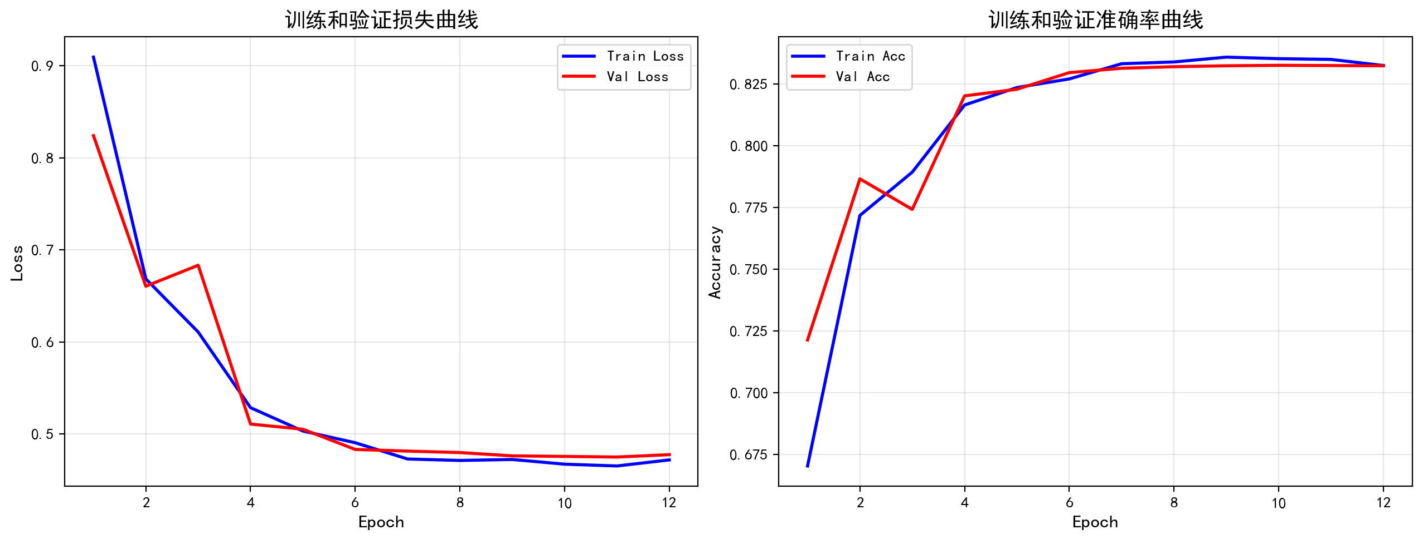

你当前最优结果来自“学习充分但不稳定”的配置
❗ 调小 step_size 虽然稳定了训练，但过早抑制了模型学习能力
🚀 下一步的关键不是继续调 step_size，而是：
👉 改学习率策略 + 解决类别不平衡

————————————————————————————————————————————————————————————————————————————————————————————————————————————————————————————————————————————————————————————————————

4.

step_size = 10
batch_size = 32
30 epoches

============================================================
4. 损失函数与优化器
============================================================
损失函数: CrossEntropyLoss（内部包含Softmax）
优化器: Adam
学习率调度: 每10轮降为原来的0.1倍

============================================================
5. 开始训练
============================================================
Epoch [ 1/30] LR: 0.00100 | Train Loss: 0.8995 | Train Acc: 0.6808 | Val Loss: 0.8410 | Val Acc: 0.7208 ★
Epoch [ 2/30] LR: 0.00100 | Train Loss: 0.6862 | Train Acc: 0.7636 | Val Loss: 0.6263 | Val Acc: 0.7751 ★
Epoch [ 3/30] LR: 0.00100 | Train Loss: 0.6184 | Train Acc: 0.7892 | Val Loss: 0.5942 | Val Acc: 0.8010 ★
Epoch [ 4/30] LR: 0.00100 | Train Loss: 0.5718 | Train Acc: 0.8080 | Val Loss: 0.7180 | Val Acc: 0.7703
Epoch [ 5/30] LR: 0.00100 | Train Loss: 0.5502 | Train Acc: 0.8120 | Val Loss: 0.6674 | Val Acc: 0.7544
Epoch [ 6/30] LR: 0.00100 | Train Loss: 0.5333 | Train Acc: 0.8137 | Val Loss: 0.5156 | Val Acc: 0.8199 ★
Epoch [ 7/30] LR: 0.00100 | Train Loss: 0.5194 | Train Acc: 0.8233 | Val Loss: 0.4872 | Val Acc: 0.8325 ★
Epoch [ 8/30] LR: 0.00100 | Train Loss: 0.5110 | Train Acc: 0.8235 | Val Loss: 0.7495 | Val Acc: 0.7569
Epoch [ 9/30] LR: 0.00100 | Train Loss: 0.5032 | Train Acc: 0.8254 | Val Loss: 0.4954 | Val Acc: 0.8370 ★
Epoch [10/30] LR: 0.00010 | Train Loss: 0.4932 | Train Acc: 0.8310 | Val Loss: 0.6333 | Val Acc: 0.7948
Epoch [11/30] LR: 0.00010 | Train Loss: 0.4385 | Train Acc: 0.8449 | Val Loss: 0.4228 | Val Acc: 0.8517 ★
Epoch [12/30] LR: 0.00010 | Train Loss: 0.4242 | Train Acc: 0.8500 | Val Loss: 0.4150 | Val Acc: 0.8556 ★
Epoch [13/30] LR: 0.00010 | Train Loss: 0.4134 | Train Acc: 0.8535 | Val Loss: 0.4108 | Val Acc: 0.8552
Epoch [14/30] LR: 0.00010 | Train Loss: 0.4050 | Train Acc: 0.8554 | Val Loss: 0.4079 | Val Acc: 0.8588 ★
Epoch [15/30] LR: 0.00010 | Train Loss: 0.3977 | Train Acc: 0.8591 | Val Loss: 0.4120 | Val Acc: 0.8575
Epoch [16/30] LR: 0.00010 | Train Loss: 0.3935 | Train Acc: 0.8582 | Val Loss: 0.4125 | Val Acc: 0.8554
Epoch [17/30] LR: 0.00010 | Train Loss: 0.3940 | Train Acc: 0.8606 | Val Loss: 0.4076 | Val Acc: 0.8587
Epoch [18/30] LR: 0.00010 | Train Loss: 0.3824 | Train Acc: 0.8628 | Val Loss: 0.4082 | Val Acc: 0.8588 ★
Epoch [19/30] LR: 0.00010 | Train Loss: 0.3836 | Train Acc: 0.8628 | Val Loss: 0.4286 | Val Acc: 0.8484
Epoch [20/30] LR: 0.00001 | Train Loss: 0.3764 | Train Acc: 0.8647 | Val Loss: 0.4005 | Val Acc: 0.8603 ★
Epoch [21/30] LR: 0.00001 | Train Loss: 0.3681 | Train Acc: 0.8663 | Val Loss: 0.3973 | Val Acc: 0.8580
Epoch [22/30] LR: 0.00001 | Train Loss: 0.3582 | Train Acc: 0.8704 | Val Loss: 0.3981 | Val Acc: 0.8577
Epoch [23/30] LR: 0.00001 | Train Loss: 0.3557 | Train Acc: 0.8717 | Val Loss: 0.3972 | Val Acc: 0.8603 ★
Epoch [24/30] LR: 0.00001 | Train Loss: 0.3561 | Train Acc: 0.8717 | Val Loss: 0.3952 | Val Acc: 0.8606 ★
Epoch [25/30] LR: 0.00001 | Train Loss: 0.3587 | Train Acc: 0.8728 | Val Loss: 0.3982 | Val Acc: 0.8597
Epoch [26/30] LR: 0.00001 | Train Loss: 0.3524 | Train Acc: 0.8751 | Val Loss: 0.3972 | Val Acc: 0.8591
Epoch [27/30] LR: 0.00001 | Train Loss: 0.3530 | Train Acc: 0.8716 | Val Loss: 0.3963 | Val Acc: 0.8594
Epoch [28/30] LR: 0.00001 | Train Loss: 0.3543 | Train Acc: 0.8725 | Val Loss: 0.3975 | Val Acc: 0.8596
Epoch [29/30] LR: 0.00001 | Train Loss: 0.3551 | Train Acc: 0.8752 | Val Loss: 0.3986 | Val Acc: 0.8579
Epoch [30/30] LR: 0.00000 | Train Loss: 0.3508 | Train Acc: 0.8733 | Val Loss: 0.3954 | Val Acc: 0.8611 ★

训练完成！最佳验证准确率: 0.8611

============================================================
6. 测试集评估
============================================================
测试集 Loss: 0.8592 测试集 Accuracy: 0.6690

============================================================
7. 绘制训练曲线
============================================================
✓ 训练曲线已保存

============================================================
8. 分类评估报告
============================================================

分类报告:
precision recall f1-score support

CNV 0.6115 0.9320 0.7385 250
DME 0.8813 0.7720 0.8230 250
DRUSEN 0.7143 0.0600 0.1107 250
NORMAL 0.6016 0.9120 0.7250 250

accuracy 0.6690 1000
macro avg 0.7022 0.6690 0.5993 1000
weighted avg 0.7022 0.6690 0.5993 1000

混淆矩阵:
[[233 13 2 2]
[ 44 193 0 13]
[ 92 7 15 136]
[ 12 6 4 228]]
✓ 混淆矩阵已保存

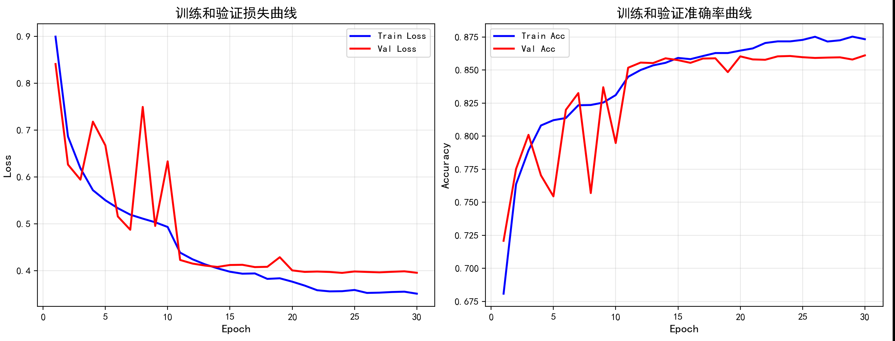

————————————————————————————————————————————————————————————————————————————————————————————————————————————————————————————————————————————————————————————————

5.
step_size = 10
batch_size = 32
30 epoches
分层训练
============================================================
4. 损失函数与优化器
============================================================
损失函数: CrossEntropyLoss（内部包含Softmax）
优化器: Adam
学习率调度: 每10轮降为原来的0.1倍

============================================================
5. 开始训练
============================================================
Epoch [ 1/30] LR: 0.00100 | Train Loss: 0.9214 | Train Acc: 0.6627 | Val Loss: 1.2200 | Val Acc: 0.5105 ★
Epoch [ 2/30] LR: 0.00100 | Train Loss: 0.6926 | Train Acc: 0.7613 | Val Loss: 0.8116 | Val Acc: 0.7048 ★
Epoch [ 3/30] LR: 0.00100 | Train Loss: 0.6109 | Train Acc: 0.7894 | Val Loss: 0.5409 | Val Acc: 0.8117 ★
Epoch [ 4/30] LR: 0.00100 | Train Loss: 0.5841 | Train Acc: 0.7972 | Val Loss: 0.5517 | Val Acc: 0.8092
Epoch [ 5/30] LR: 0.00100 | Train Loss: 0.5647 | Train Acc: 0.8056 | Val Loss: 0.8414 | Val Acc: 0.7273
Epoch [ 6/30] LR: 0.00100 | Train Loss: 0.5538 | Train Acc: 0.8082 | Val Loss: 0.5153 | Val Acc: 0.8262 ★
Epoch [ 7/30] LR: 0.00100 | Train Loss: 0.5354 | Train Acc: 0.8133 | Val Loss: 1.0103 | Val Acc: 0.6904
Epoch [ 8/30] LR: 0.00100 | Train Loss: 0.5264 | Train Acc: 0.8179 | Val Loss: 0.5308 | Val Acc: 0.8250
Epoch [10/30] LR: 0.00010 | Train Loss: 0.5080 | Train Acc: 0.8244 | Val Loss: 0.7461 | Val Acc: 0.7682
Epoch [11/30] LR: 0.00010 | Train Loss: 0.4502 | Train Acc: 0.8390 | Val Loss: 0.4325 | Val Acc: 0.8501 ★
Epoch [12/30] LR: 0.00010 | Train Loss: 0.4342 | Train Acc: 0.8468 | Val Loss: 0.4298 | Val Acc: 0.8486
Epoch [13/30] LR: 0.00010 | Train Loss: 0.4149 | Train Acc: 0.8511 | Val Loss: 0.4256 | Val Acc: 0.8514 ★
Epoch [14/30] LR: 0.00010 | Train Loss: 0.4116 | Train Acc: 0.8511 | Val Loss: 0.4235 | Val Acc: 0.8543 ★
Epoch [15/30] LR: 0.00010 | Train Loss: 0.4058 | Train Acc: 0.8552 | Val Loss: 0.4176 | Val Acc: 0.8543 ★
Epoch [16/30] LR: 0.00010 | Train Loss: 0.4008 | Train Acc: 0.8559 | Val Loss: 0.4237 | Val Acc: 0.8526
Epoch [17/30] LR: 0.00010 | Train Loss: 0.3934 | Train Acc: 0.8568 | Val Loss: 0.4182 | Val Acc: 0.8547 ★
Epoch [18/30] LR: 0.00010 | Train Loss: 0.3907 | Train Acc: 0.8609 | Val Loss: 0.4167 | Val Acc: 0.8552 ★
Epoch [19/30] LR: 0.00010 | Train Loss: 0.3870 | Train Acc: 0.8585 | Val Loss: 0.4105 | Val Acc: 0.8573 ★
Epoch [20/30] LR: 0.00001 | Train Loss: 0.3914 | Train Acc: 0.8609 | Val Loss: 0.4238 | Val Acc: 0.8526
Epoch [21/30] LR: 0.00001 | Train Loss: 0.3723 | Train Acc: 0.8666 | Val Loss: 0.4025 | Val Acc: 0.8621 ★
Epoch [22/30] LR: 0.00001 | Train Loss: 0.3700 | Train Acc: 0.8650 | Val Loss: 0.4064 | Val Acc: 0.8610
Epoch [23/30] LR: 0.00001 | Train Loss: 0.3653 | Train Acc: 0.8677 | Val Loss: 0.4041 | Val Acc: 0.8621 ★
Epoch [24/30] LR: 0.00001 | Train Loss: 0.3669 | Train Acc: 0.8646 | Val Loss: 0.4050 | Val Acc: 0.8570
Epoch [25/30] LR: 0.00001 | Train Loss: 0.3661 | Train Acc: 0.8679 | Val Loss: 0.4074 | Val Acc: 0.8593
Epoch [26/30] LR: 0.00001 | Train Loss: 0.3607 | Train Acc: 0.8679 | Val Loss: 0.4021 | Val Acc: 0.8623 ★
Epoch [27/30] LR: 0.00001 | Train Loss: 0.3644 | Train Acc: 0.8666 | Val Loss: 0.4110 | Val Acc: 0.8591
Epoch [28/30] LR: 0.00001 | Train Loss: 0.3646 | Train Acc: 0.8675 | Val Loss: 0.4043 | Val Acc: 0.8596
Epoch [29/30] LR: 0.00001 | Train Loss: 0.3588 | Train Acc: 0.8710 | Val Loss: 0.4029 | Val Acc: 0.8610
Epoch [30/30] LR: 0.00000 | Train Loss: 0.3580 | Train Acc: 0.8697 | Val Loss: 0.4041 | Val Acc: 0.8602

训练完成！最佳验证准确率: 0.8623

============================================================
6. 测试集评估
============================================================
测试集 Loss: 0.8043 测试集 Accuracy: 0.6910

============================================================
7. 绘制训练曲线
============================================================
✓ 训练曲线已保存

============================================================
8. 分类评估报告
============================================================

分类报告:
precision recall f1-score support

CNV 0.6532 0.9040 0.7584 250
DME 0.8841 0.8240 0.8530 250
DRUSEN 0.7500 0.0960 0.1702 250
NORMAL 0.6041 0.9400 0.7355 250

accuracy 0.6910 1000
macro avg 0.7229 0.6910 0.6293 1000
weighted avg 0.7229 0.6910 0.6293 1000

混淆矩阵:
[[226 18 2 4]
[ 31 206 0 13]
[ 82 7 24 137]
[ 7 2 6 235]]
✓ 混淆矩阵已保存

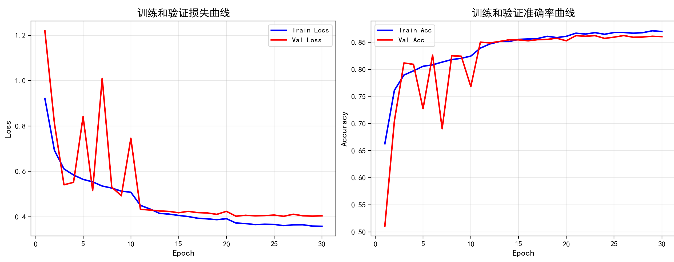
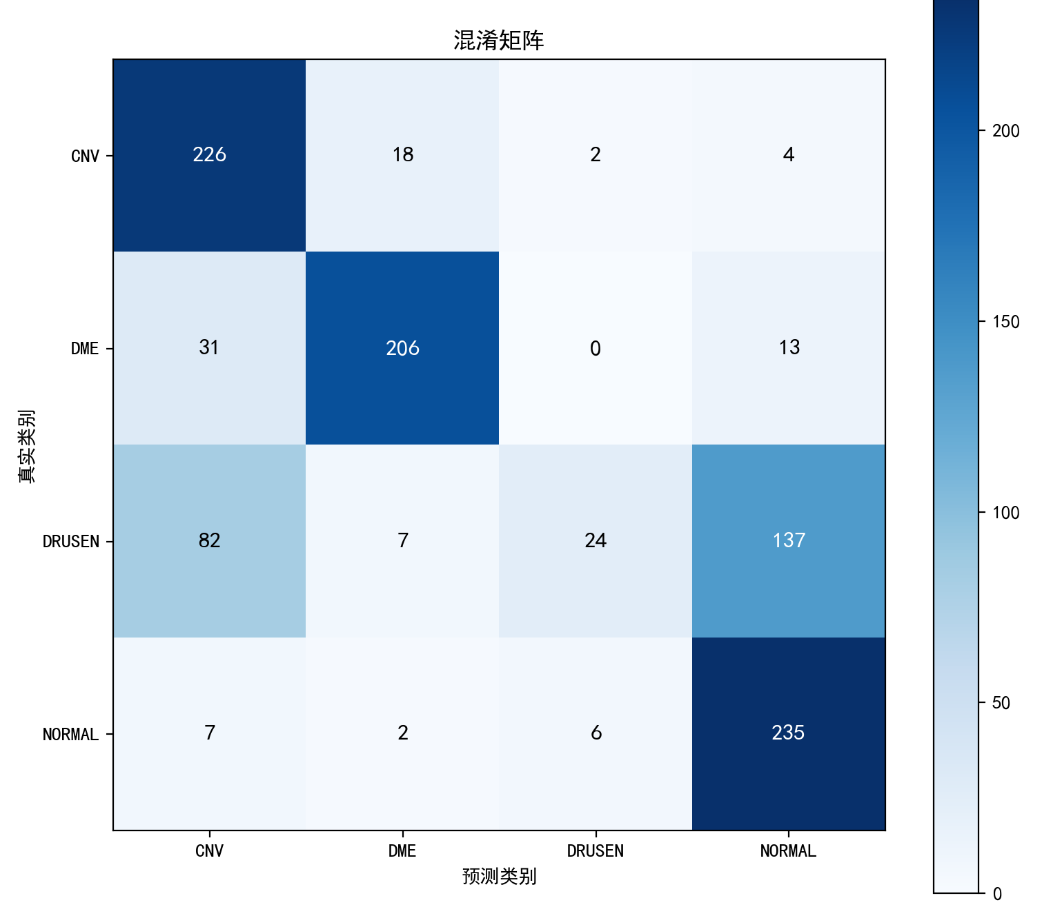

6.
step_size = 10
batch_size = 32
30 epoches
分层训练
更改权重1151

============================================================
4. 损失函数与优化器
============================================================
损失函数: CrossEntropyLoss（内部包含Softmax）
优化器: Adam
学习率调度: 每10轮降为原来的0.1倍

============================================================
5. 开始训练
============================================================

Epoch [ 1/30] LR: 0.00100 | Train Loss: 1.1414 | Train Acc: 0.5617 | Val Loss: 1.0028 | Val Acc: 0.6991 ★

Epoch [ 2/30] LR: 0.00100 | Train Loss: 0.9569 | Train Acc: 0.6507 | Val Loss: 1.0082 | Val Acc: 0.5358

Epoch [ 3/30] LR: 0.00100 | Train Loss: 0.8547 | Train Acc: 0.6778 | Val Loss: 0.8163 | Val Acc: 0.6928
Epoch [ 4/30] LR: 0.00100 | Train Loss: 0.8073 | Train Acc: 0.6954 | Val Loss: 0.7331 | Val Acc: 0.7152 ★
Epoch [ 5/30] LR: 0.00100 | Train Loss: 0.7995 | Train Acc: 0.7031 | Val Loss: 0.8980 | Val Acc: 0.5626
Epoch [ 6/30] LR: 0.00100 | Train Loss: 0.7743 | Train Acc: 0.7105 | Val Loss: 0.7285 | Val Acc: 0.7744 ★
Epoch [ 7/30] LR: 0.00100 | Train Loss: 0.7502 | Train Acc: 0.7190 | Val Loss: 0.7593 | Val Acc: 0.7785 ★
Epoch [ 8/30] LR: 0.00100 | Train Loss: 0.7452 | Train Acc: 0.7189 | Val Loss: 0.8872 | Val Acc: 0.5377
Epoch [ 9/30] LR: 0.00100 | Train Loss: 0.7111 | Train Acc: 0.7239 | Val Loss: 0.8633 | Val Acc: 0.7174
Epoch [10/30] LR: 0.00010 | Train Loss: 0.6917 | Train Acc: 0.7395 | Val Loss: 0.8122 | Val Acc: 0.7737
Epoch [11/30] LR: 0.00010 | Train Loss: 0.6438 | Train Acc: 0.7575 | Val Loss: 0.6226 | Val Acc: 0.7919 ★
Epoch [12/30] LR: 0.00010 | Train Loss: 0.6204 | Train Acc: 0.7680 | Val Loss: 0.6130 | Val Acc: 0.7867
Epoch [13/30] LR: 0.00010 | Train Loss: 0.6146 | Train Acc: 0.7633 | Val Loss: 0.6082 | Val Acc: 0.7841
Epoch [14/30] LR: 0.00010 | Train Loss: 0.6107 | Train Acc: 0.7708 | Val Loss: 0.6140 | Val Acc: 0.7902
Epoch [15/30] LR: 0.00010 | Train Loss: 0.6071 | Train Acc: 0.7740 | Val Loss: 0.6060 | Val Acc: 0.7801
Epoch [16/30] LR: 0.00010 | Train Loss: 0.5907 | Train Acc: 0.7778 | Val Loss: 0.6065 | Val Acc: 0.7960 ★
Epoch [17/30] LR: 0.00010 | Train Loss: 0.5664 | Train Acc: 0.7870 | Val Loss: 0.6084 | Val Acc: 0.7868
Epoch [18/30] LR: 0.00010 | Train Loss: 0.5734 | Train Acc: 0.7864 | Val Loss: 0.6010 | Val Acc: 0.7920
Epoch [19/30] LR: 0.00010 | Train Loss: 0.5657 | Train Acc: 0.7836 | Val Loss: 0.6074 | Val Acc: 0.7976 ★
Epoch [20/30] LR: 0.00001 | Train Loss: 0.5623 | Train Acc: 0.7909 | Val Loss: 0.6054 | Val Acc: 0.7963
Epoch [21/30] LR: 0.00001 | Train Loss: 0.5426 | Train Acc: 0.7954 | Val Loss: 0.5993 | Val Acc: 0.7868
Epoch [22/30] LR: 0.00001 | Train Loss: 0.5486 | Train Acc: 0.8000 | Val Loss: 0.6007 | Val Acc: 0.7915
Epoch [23/30] LR: 0.00001 | Train Loss: 0.5526 | Train Acc: 0.7923 | Val Loss: 0.5964 | Val Acc: 0.7924
Epoch [24/30] LR: 0.00001 | Train Loss: 0.5393 | Train Acc: 0.7972 | Val Loss: 0.6021 | Val Acc: 0.7854
Epoch [25/30] LR: 0.00001 | Train Loss: 0.5401 | Train Acc: 0.8029 | Val Loss: 0.5986 | Val Acc: 0.7987 ★
Epoch [26/30] LR: 0.00001 | Train Loss: 0.5321 | Train Acc: 0.8029 | Val Loss: 0.5965 | Val Acc: 0.7963
Epoch [27/30] LR: 0.00001 | Train Loss: 0.5311 | Train Acc: 0.8035 | Val Loss: 0.5978 | Val Acc: 0.7920
Epoch [28/30] LR: 0.00001 | Train Loss: 0.5308 | Train Acc: 0.8007 | Val Loss: 0.6012 | Val Acc: 0.7947
Epoch [29/30] LR: 0.00001 | Train Loss: 0.5372 | Train Acc: 0.8006 | Val Loss: 0.5948 | Val Acc: 0.7877
Epoch [30/30] LR: 0.00000 | Train Loss: 0.5332 | Train Acc: 0.8020 | Val Loss: 0.5974 | Val Acc: 0.7896

训练完成！最佳验证准确率: 0.7987

============================================================
6. 测试集评估
============================================================
测试集 Loss: 1.2176
测试集 Accuracy: 0.7260

============================================================
7. 绘制训练曲线
============================================================
✓ 训练曲线已保存

============================================================
8. 分类评估报告
============================================================

分类报告:
precision recall f1-score support

CNV 0.6628 0.9200 0.7705 250
DME 0.8874 0.7880 0.8347 250
DRUSEN 0.7031 0.3600 0.4762 250
NORMAL 0.6898 0.8360 0.7559 250

accuracy 0.7260 1000
macro avg 0.7358 0.7260 0.7093 1000
weighted avg 0.7358 0.7260 0.7093 1000

混淆矩阵:
[[230 15 3 2]
[ 36 197 4 13]
[ 74 7 90 79]
[ 7 3 31 209]]
✓ 混淆矩阵已保存

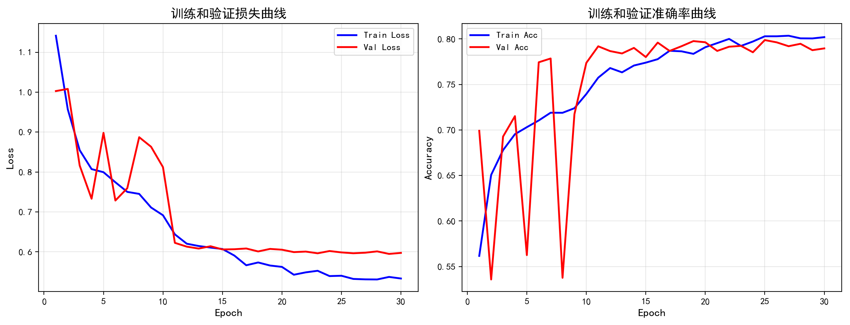
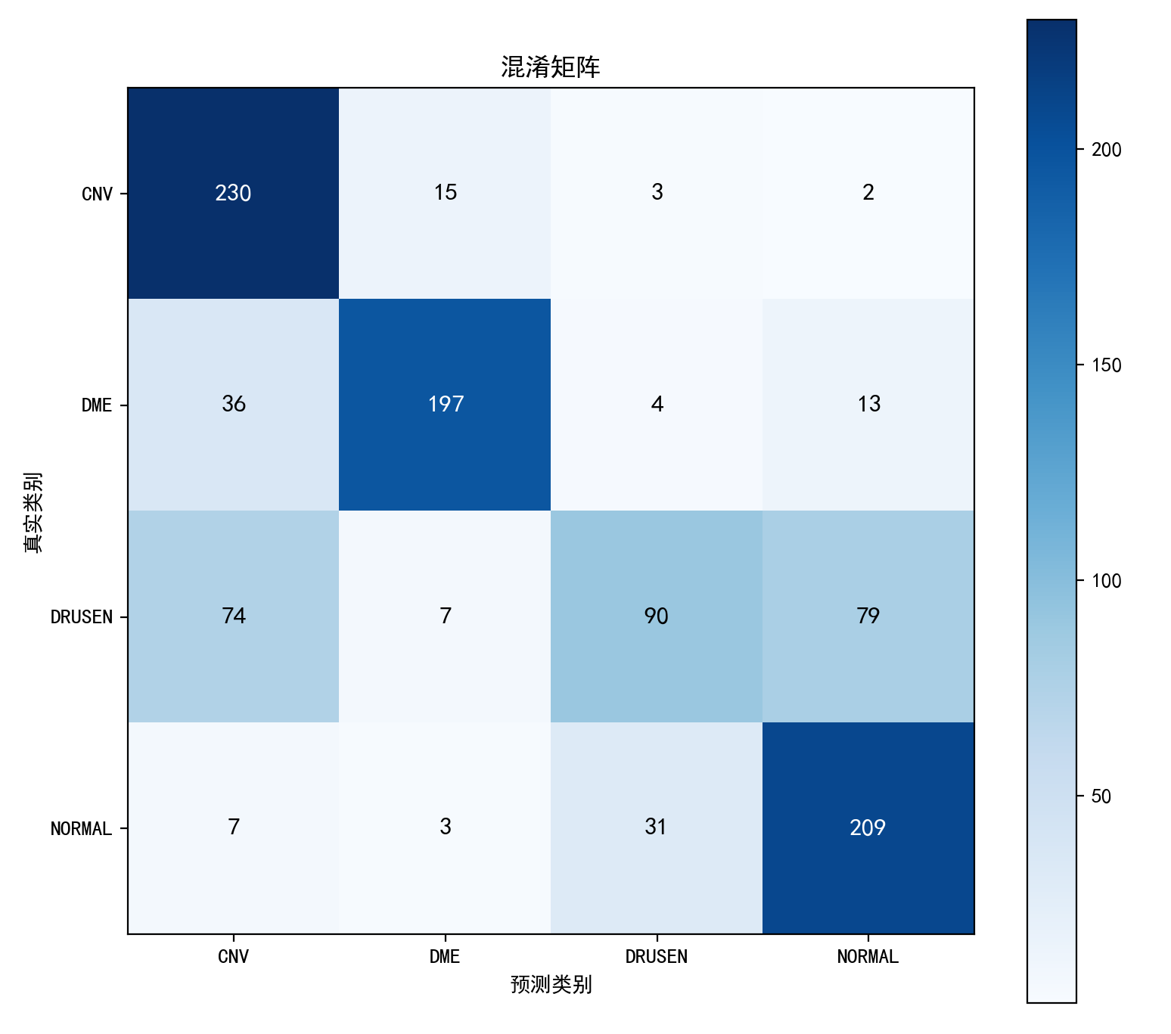
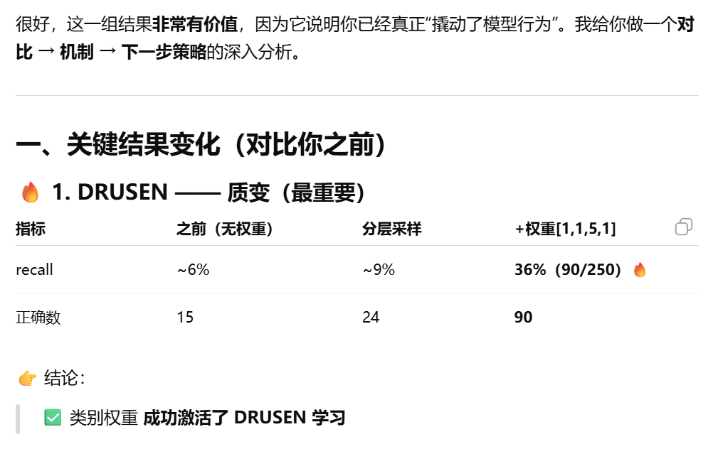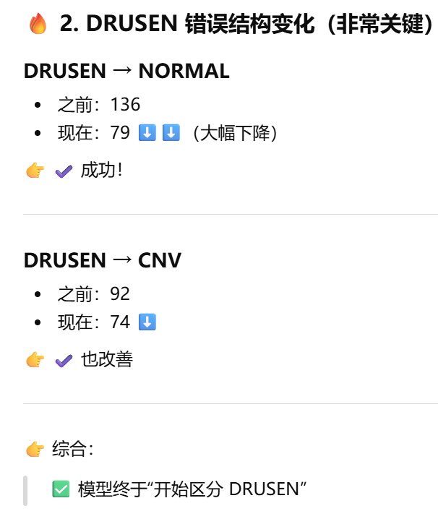
✅ 已经从“忽略 DRUSEN” → “强制学习 DRUSEN”
❗ 但变成“过度敏感 DRUSEN”
问题1：过补偿（over-compensation）
DRUSEN 权重 = 5
👉 结果：
模型倾向：
“多预测 DRUSEN，避免被惩罚”

7.
step_size = 10
batch_size = 32
data_fraction = 0.2
30 epoches
分层训练
更改权重1131

============================================================
4. 损失函数与优化器
============================================================
损失函数: CrossEntropyLoss（内部包含Softmax）
优化器: Adam
学习率调度: 每10轮降为原来的0.1倍

============================================================
5. 开始训练
============================================================

Epoch [ 1/30] LR: 0.00100 | Train Loss: 0.9880 | Train Acc: 0.6757 | Val Loss: 0.7875 | Val Acc: 0.6665 ★
Epoch [ 2/30] LR: 0.00100 | Train Loss: 0.7691 | Train Acc: 0.7494 | Val Loss: 0.6927 | Val Acc: 0.7709 ★
Epoch [ 3/30] LR: 0.00100 | Train Loss: 0.7110 | Train Acc: 0.7692 | Val Loss: 0.8245 | Val Acc: 0.7832 ★
Epoch [ 4/30] LR: 0.00100 | Train Loss: 0.6879 | Train Acc: 0.7797 | Val Loss: 0.6516 | Val Acc: 0.8064 ★
Epoch [ 5/30] LR: 0.00100 | Train Loss: 0.6618 | Train Acc: 0.7875 | Val Loss: 0.6055 | Val Acc: 0.8056
Epoch [ 6/30] LR: 0.00100 | Train Loss: 0.6645 | Train Acc: 0.7879 | Val Loss: 0.8078 | Val Acc: 0.7126
Epoch [ 7/30] LR: 0.00100 | Train Loss: 0.6404 | Train Acc: 0.7962 | Val Loss: 0.6850 | Val Acc: 0.7998
Epoch [ 8/30] LR: 0.00100 | Train Loss: 0.6209 | Train Acc: 0.7991 | Val Loss: 0.6615 | Val Acc: 0.7816
Epoch [ 9/30] LR: 0.00100 | Train Loss: 0.6036 | Train Acc: 0.8023 | Val Loss: 0.5522 | Val Acc: 0.8169 ★
Epoch [10/30] LR: 0.00010 | Train Loss: 0.6180 | Train Acc: 0.8008 | Val Loss: 0.5503 | Val Acc: 0.8405 ★
Epoch [11/30] LR: 0.00010 | Train Loss: 0.5492 | Train Acc: 0.8197 | Val Loss: 0.5156 | Val Acc: 0.8371
Epoch [12/30] LR: 0.00010 | Train Loss: 0.5313 | Train Acc: 0.8272 | Val Loss: 0.5179 | Val Acc: 0.8335
Epoch [13/30] LR: 0.00010 | Train Loss: 0.5103 | Train Acc: 0.8343 | Val Loss: 0.5067 | Val Acc: 0.8381
Epoch [14/30] LR: 0.00010 | Train Loss: 0.5071 | Train Acc: 0.8386 | Val Loss: 0.5020 | Val Acc: 0.8421 ★
Epoch [15/30] LR: 0.00010 | Train Loss: 0.5027 | Train Acc: 0.8400 | Val Loss: 0.5055 | Val Acc: 0.8455 ★
Epoch [16/30] LR: 0.00010 | Train Loss: 0.4961 | Train Acc: 0.8391 | Val Loss: 0.4975 | Val Acc: 0.8362
Epoch [17/30] LR: 0.00010 | Train Loss: 0.4932 | Train Acc: 0.8419 | Val Loss: 0.4967 | Val Acc: 0.8435
Epoch [18/30] LR: 0.00010 | Train Loss: 0.4852 | Train Acc: 0.8463 | Val Loss: 0.5327 | Val Acc: 0.8457 ★
Epoch [19/30] LR: 0.00010 | Train Loss: 0.4837 | Train Acc: 0.8456 | Val Loss: 0.4914 | Val Acc: 0.8401
Epoch [20/30] LR: 0.00001 | Train Loss: 0.4754 | Train Acc: 0.8471 | Val Loss: 0.4980 | Val Acc: 0.8398
Epoch [21/30] LR: 0.00001 | Train Loss: 0.4675 | Train Acc: 0.8488 | Val Loss: 0.4875 | Val Acc: 0.8485 ★
Epoch [22/30] LR: 0.00001 | Train Loss: 0.4644 | Train Acc: 0.8526 | Val Loss: 0.4922 | Val Acc: 0.8528 ★
Epoch [23/30] LR: 0.00001 | Train Loss: 0.4639 | Train Acc: 0.8513 | Val Loss: 0.4889 | Val Acc: 0.8448
Epoch [24/30] LR: 0.00001 | Train Loss: 0.4641 | Train Acc: 0.8477 | Val Loss: 0.4859 | Val Acc: 0.8443
Epoch [25/30] LR: 0.00001 | Train Loss: 0.4656 | Train Acc: 0.8529 | Val Loss: 0.4862 | Val Acc: 0.8427
Epoch [26/30] LR: 0.00001 | Train Loss: 0.4614 | Train Acc: 0.8520 | Val Loss: 0.4865 | Val Acc: 0.8451
Epoch [27/30] LR: 0.00001 | Train Loss: 0.4598 | Train Acc: 0.8538 | Val Loss: 0.4891 | Val Acc: 0.8456
Epoch [28/30] LR: 0.00001 | Train Loss: 0.4594 | Train Acc: 0.8525 | Val Loss: 0.4848 | Val Acc: 0.8461
Epoch [29/30] LR: 0.00001 | Train Loss: 0.4554 | Train Acc: 0.8534 | Val Loss: 0.4848 | Val Acc: 0.8446
Epoch [30/30] LR: 0.00000 | Train Loss: 0.4595 | Train Acc: 0.8520 | Val Loss: 0.4846 | Val Acc: 0.8504

训练完成！最佳验证准确率: 0.8528

============================================================
6. 测试集评估
============================================================
测试集 Loss: 1.1168
测试集 Accuracy: 0.7250

============================================================
7. 绘制训练曲线
============================================================
✓ 训练曲线已保存

============================================================
8. 分类评估报告
============================================================

分类报告:
precision recall f1-score support

CNV 0.6388 0.9480 0.7633 250
DME 0.9242 0.7800 0.8460 250
DRUSEN 0.7551 0.2960 0.4253 250
NORMAL 0.6844 0.8760 0.7684 250

accuracy 0.7250 1000
macro avg 0.7506 0.7250 0.7007 1000
weighted avg 0.7506 0.7250 0.7007 1000

混淆矩阵:
[[237 7 3 3]
[ 42 195 5 8]
[ 80 6 74 90]
[ 12 3 16 219]]
✓ 混淆矩阵已保存
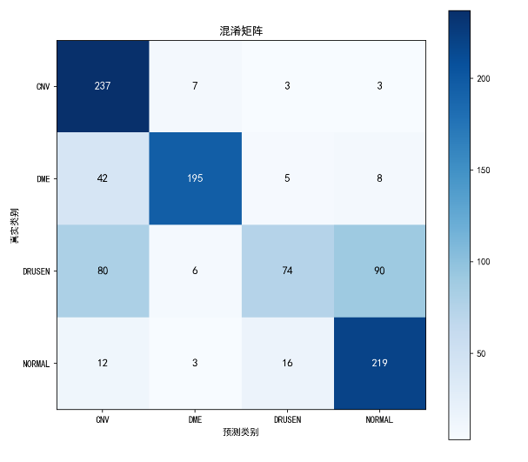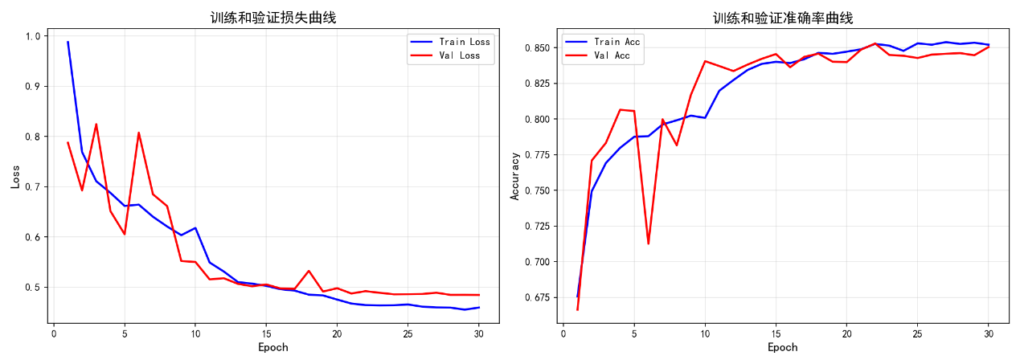

8.
step_size = 10
batch_size = 32
data_fraction = 0.2
image_size = 64

30 epoches
分层训练
更改权重1131

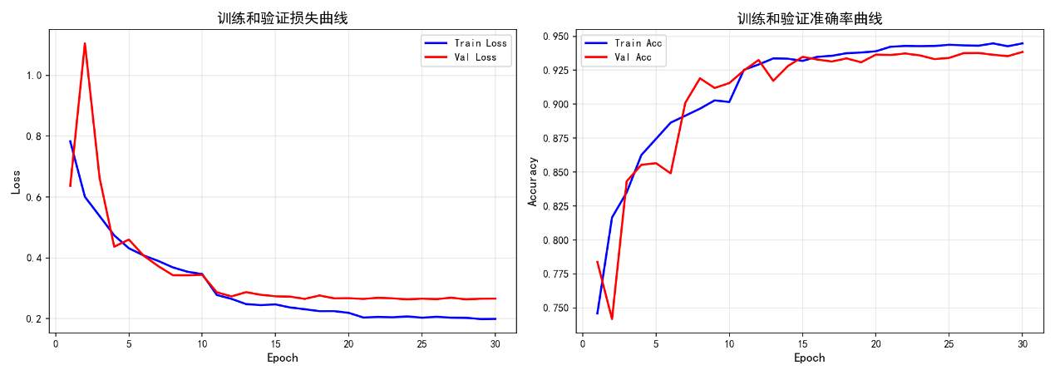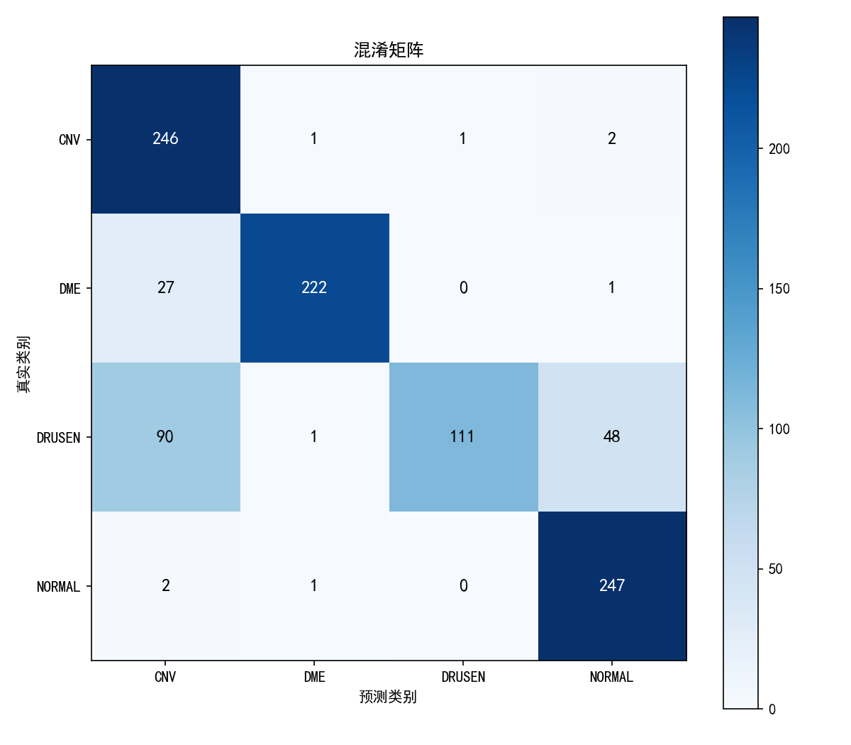

9.
step_size = 10
batch_size = 32
data_fraction = 0.2
image_size = 64

30 epoches
分层训练
更改权重1131

============================================================
4. 损失函数与优化器
============================================================
损失函数: CrossEntropyLoss（内部包含Softmax）
优化器: Adam
学习率调度: 每10轮降为原来的0.1倍

============================================================
5. 开始训练
============================================================
Epoch [ 1/30] LR: 0.00100 | Train Loss: 0.8799 | Train Acc: 0.7107 | Val Loss: 0.6751 | Val Acc: 0.8152 ★
Epoch [ 2/30] LR: 0.00100 | Train Loss: 0.6931 | Train Acc: 0.7795 | Val Loss: 0.8137 | Val Acc: 0.7378
Epoch [ 3/30] LR: 0.00100 | Train Loss: 0.6227 | Train Acc: 0.8027 | Val Loss: 0.5616 | Val Acc: 0.8529 ★
Epoch [ 4/30] LR: 0.00100 | Train Loss: 0.5700 | Train Acc: 0.8222 | Val Loss: 0.5052 | Val Acc: 0.8671 ★
Epoch [ 5/30] LR: 0.00100 | Train Loss: 0.5315 | Train Acc: 0.8404 | Val Loss: 0.5534 | Val Acc: 0.8665
Epoch [ 7/30] LR: 0.00100 | Train Loss: 0.4814 | Train Acc: 0.8565 | Val Loss: 0.6184 | Val Acc: 0.8612
Epoch [ 8/30] LR: 0.00100 | Train Loss: 0.4526 | Train Acc: 0.8677 | Val Loss: 0.4173 | Val Acc: 0.8685
Epoch [ 9/30] LR: 0.00100 | Train Loss: 0.4304 | Train Acc: 0.8683 | Val Loss: 0.4132 | Val Acc: 0.8795 ★
Epoch [10/30] LR: 0.00010 | Train Loss: 0.4170 | Train Acc: 0.8827 | Val Loss: 0.5043 | Val Acc: 0.8846 ★
============================================================
第 10 轮 - 当前最佳Validation混淆矩阵 (Val Acc: 0.8846)
============================================================
混淆矩阵:
CNV DME DRUSEN NORMAL 总计
CNV 3507 75 94 45 3721
DME 126 891 13 105 1135
DRUSEN 137 18 345 362 862
NORMAL 147 116 12 4839 5114
总计 3917 1100 464 5351 10832

各类别准确率:
CNV: 0.9425 (3507/3721)
DME: 0.7850 (891/1135)
DRUSEN: 0.4002 (345/862)
NORMAL: 0.9462 (4839/5114)

简要分类报告:
precision recall f1-score support

CNV 0.8953 0.9425 0.9183 3721
DME 0.8100 0.7850 0.7973 1135
DRUSEN 0.7435 0.4002 0.5204 862
NORMAL 0.9043 0.9462 0.9248 5114

accuracy 0.8846 10832
macro avg 0.8383 0.7685 0.7902 10832
weighted avg 0.8786 0.8846 0.8770 10832

============================================================
Epoch [11/30] LR: 0.00010 | Train Loss: 0.3426 | Train Acc: 0.9006 | Val Loss: 0.3625 | Val Acc: 0.9081 ★
Epoch [12/30] LR: 0.00010 | Train Loss: 0.3134 | Train Acc: 0.9119 | Val Loss: 0.3504 | Val Acc: 0.9129 ★
Epoch [13/30] LR: 0.00010 | Train Loss: 0.2986 | Train Acc: 0.9139 | Val Loss: 0.3511 | Val Acc: 0.9140 ★
Epoch [14/30] LR: 0.00010 | Train Loss: 0.2927 | Train Acc: 0.9146 | Val Loss: 0.3482 | Val Acc: 0.9148 ★
Epoch [15/30] LR: 0.00010 | Train Loss: 0.2914 | Train Acc: 0.9154 | Val Loss: 0.3422 | Val Acc: 0.9150 ★

